**GET DATA FROM REST API USING**

**ALEXA SKILL**

**What is an Alexa Skill?**

The Amazon Echo is a hands-free speaker you control with your voice. Alexa is the voice service that powers Echo and allows customers to interact with the device. As third-party developers, we can create apps, or, in this case, "skills" that users can download and interact with. An Alexa skill might help you find a good book while another might give you information about your favourite TV Show. The possibilities are endless!

**Prerequisites**

* An Amazon developer account, created one [here](https://developer.amazon.com/login.html) if needed
  + This is required for building and managing skills
  + This is also required if you plan to use Login with Amazon (LWA) as your OAuth provider. OAuth integration is required for Smart Home skills
  + This is an Amazon account, so it can also be used as an Alexa user for testing
* An Alexa-enabled device associated with the above account
  + This can be an [Amazon device with Alexa](https://www.amazon.com/gp/browse.html?node=9818047011&ref_=fs_ods_fs_aucc_cp&pldnSite=1), or an [Alexa Voice Service (AVS) enabled device](https://www.amazon.com/b/ref=cp_aucc_ods?node=15443147011)
  + This can also be a virtual device like [echosim.io](https://echosim.io/) or [reverb.ai](https://reverb.ai/)
* An AWS account -- create one [here](https://console.aws.amazon.com/console/home) if needed
  + This is required for building and hosting [Lambda](https://aws.amazon.com/lambda/) functions, which are required for Smart Home skills.

# **Five Steps to setup Alexa Skill**

Please refer to our [official documentation](https://developer.amazon.com/public/solutions/alexa/alexa-skills-kit/docs/steps-to-create-a-smart-home-skill) for detailed steps to creating a skill. However, it boils down to the following five easy steps:

1. Create the skill
2. Create the Lambda function
3. Configure the skill
4. Test

# **Create the skill**

1. Go to <https://developer.amazon.com/login.html> and sign in
2. Go to Alexa > Alexa Skills Kit (Get Started) > Add a New Skill
3. In the Skill Information tab:
   * Name = ( whatever you want)
   * Model Type = custom
   * Click Save

This creates the skill. Note the skill ID will be on “Endpoint” column -> copy skill-id to create LAMBDA function.

Skill ID:

1. In the interaction model, give INVOCATION name (to invoke Alexa).
2. Create INTENTS and also if you want to create Slots for your INTENTS.
3. Sample Utterances, enter all the phrases that you think users might say to interact with your skill. The more phrases you enter, the better the results. For our example, paste the following:

* Get my number
* Get my status {slot Name}
* Create model

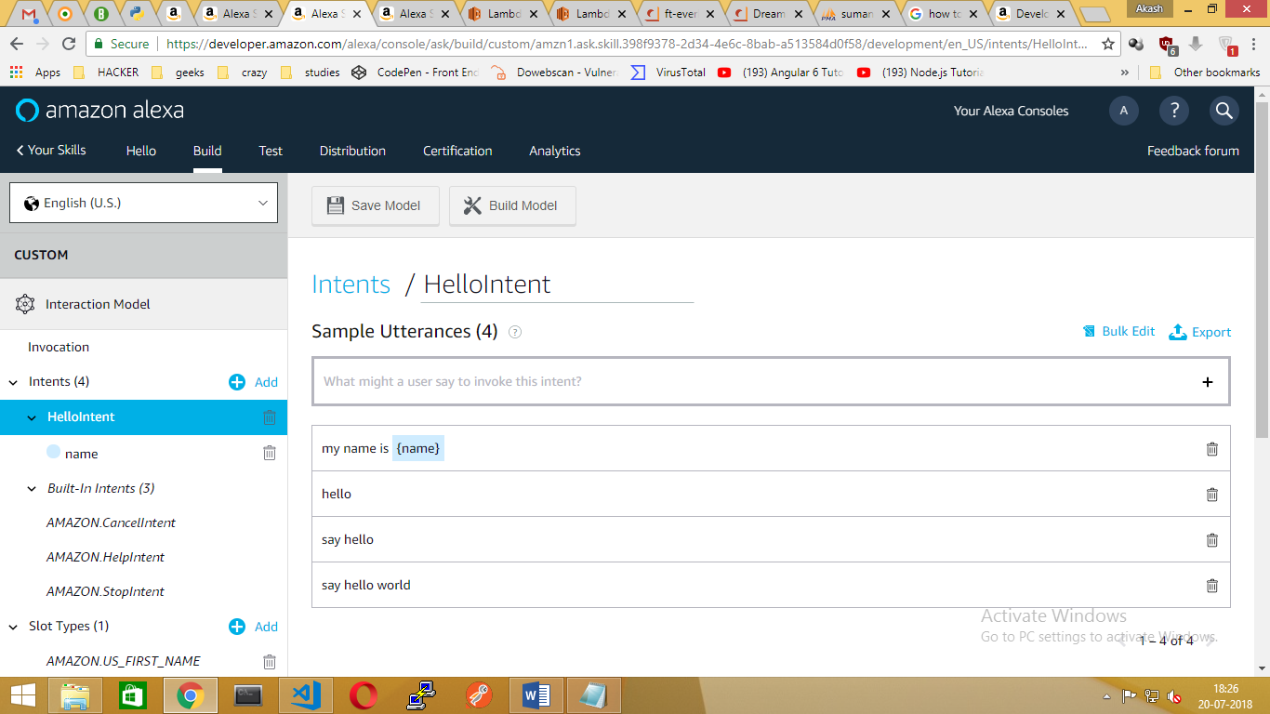

**(OR)**

We can also Create Interaction Model using JSON file

1. Go to Interaction Model section, Scroll down to JSON Editor and Paste the JSON Contents into it.



1. Finally, click “save model”.

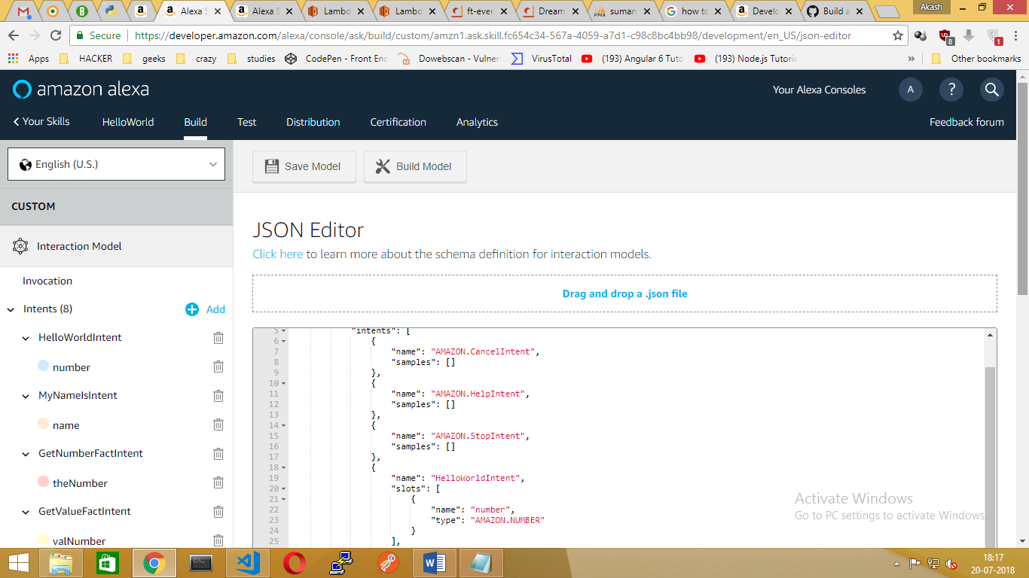

# **Create the Lambda function**

Now let's setup the Lambda function:

1. Go to <https://console.aws.amazon.com/console/home> and sign in
2. Go to Services > Compute > Lambda
3. Click on Create Function
4. Step 1: Click on Author from scratch
5. Step 2: Configure your Lambda function
   * Name = SampleLambdaFunction (or whatever you want)
   * Role = Create a Custom Role which will launch a new tab. Click Allow to create a new role named lambda_basic_execution and automatically insert this role into the Lambda basic information dialog.
   * Click Create Function
6. Step 3: Click Triggers -> Add Trigger and select “Alexa Skill Set”
   * Application Id = skill ID of your test skill that you noted above(from ENDPOINTS in Interaction Model)
   * Enable trigger = checked
   * Click Add
7. Step 4: Click Configuration
   * Runtime = (you can choose whatever you want. (.ie.nodejs)
   * Code entry type = Upload a .ZIP file
   * Click on Upload and find the **FILENAME.zip** (Contains **Index.js** & **node modules** Folder) you created earlier



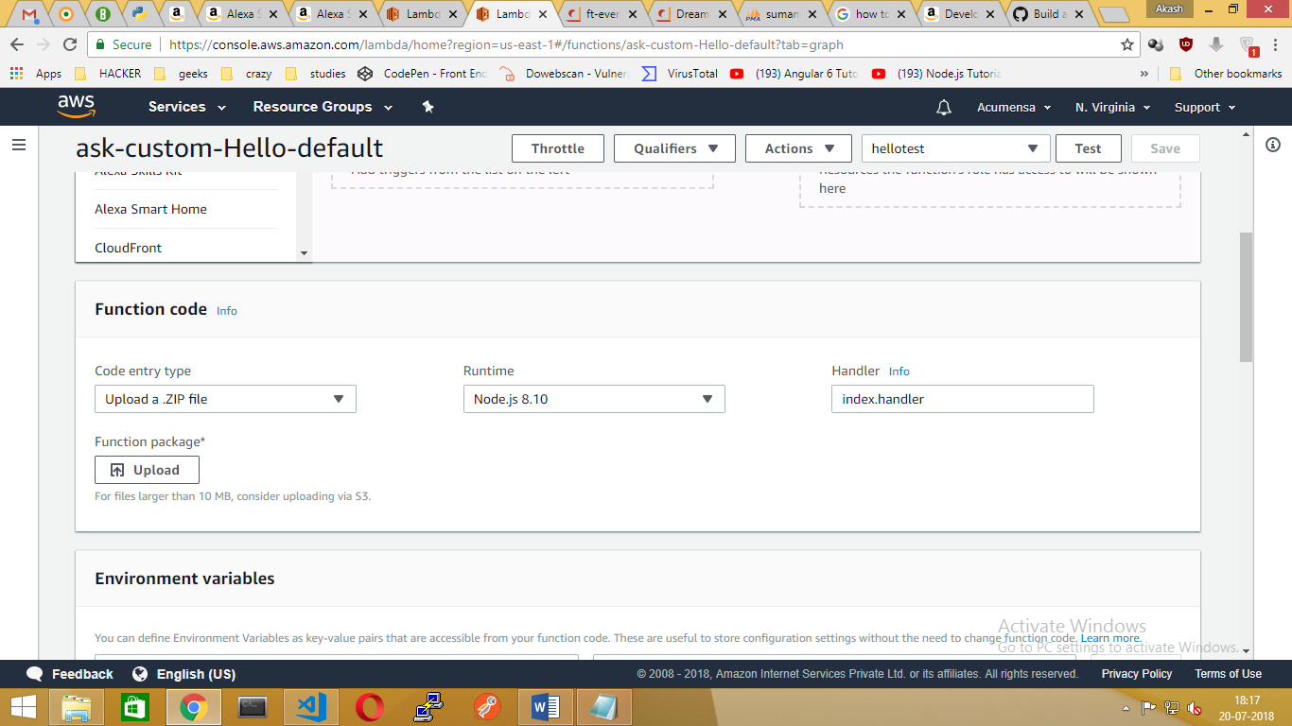

* + Click Upload
  + Click Save

1. Lambda ARN:
   * On the top right corner, note the Lambda ARN
   * Copy_ARN:arn:aws:lambda:us-east-1:970252137606:function:ask-custom-Hello-default

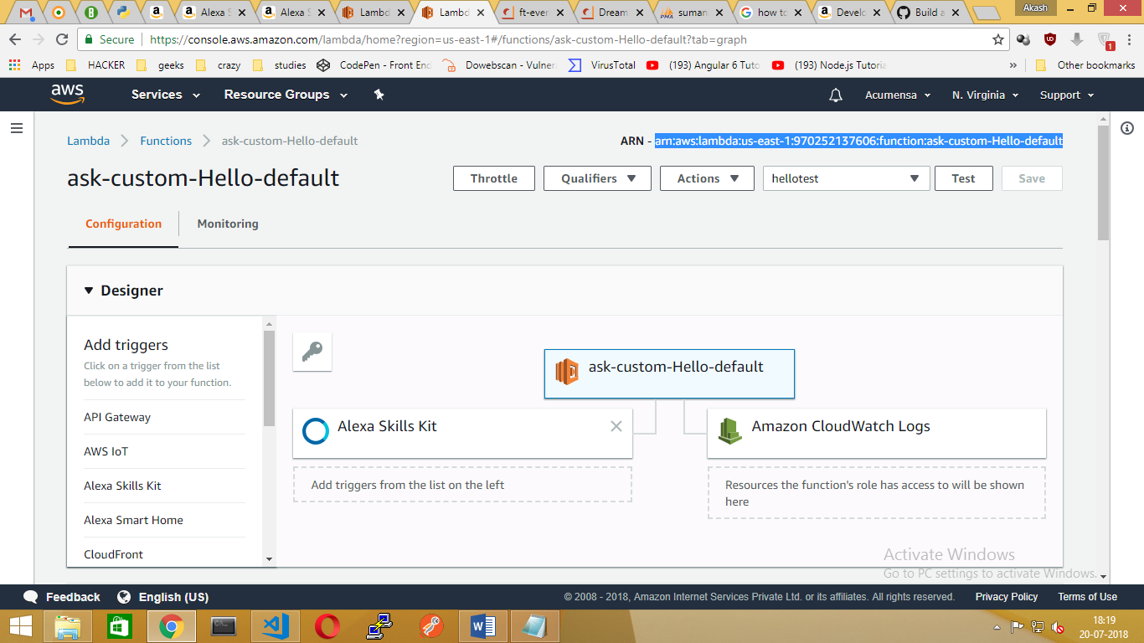

# **Configure skill**

* + Go back to <https://developer.amazon.com/home.html> and sign in as needed
  + Go to Alexa > Alexa Skills Kit > the test skill you created earlier
  + In the Configuration tab:
  + Lambda ARN default = enter your Lambda ARN noted from the previous step

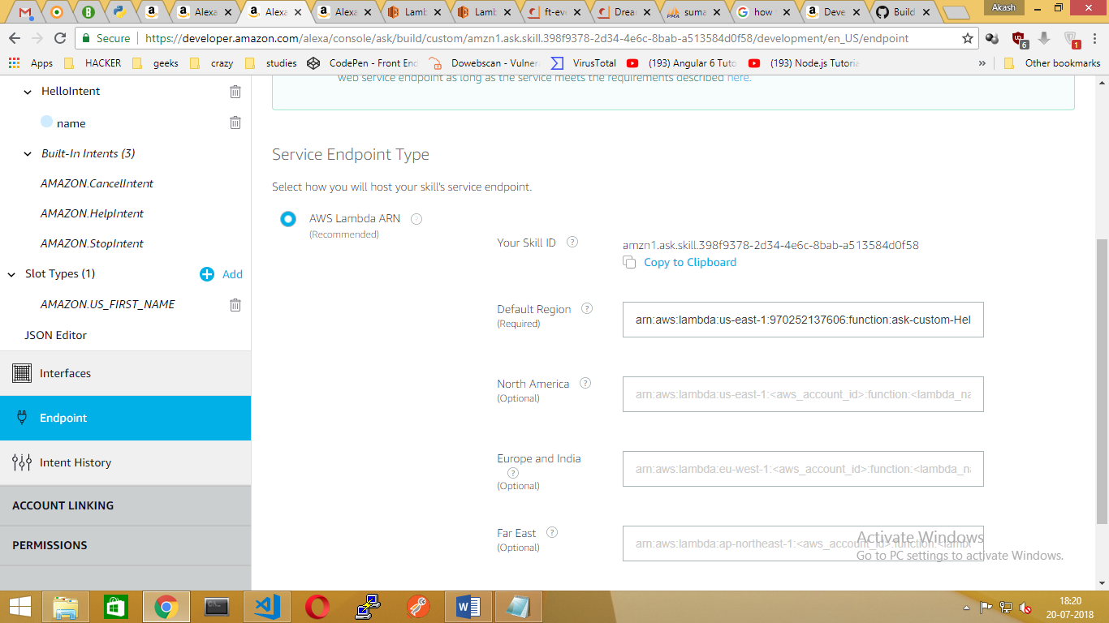

* + Finally, Click Save Endpoints.
  + At last, Click “Build Model” in Invocation Name